ART ACTIVITIES
STEAM ACTIVITY:
FLEXTANGLES
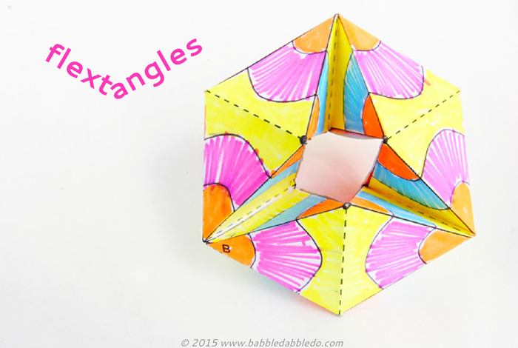
https://babbledabbledo.com/paper-toys-flextangles/

I love this activity!!! Make sure to crease the paper on the lines very carefully in order for it to work properly. You can download the template from the website above. It also has a video so you can have a visual example. Enjoy!!!

ART ACTIVITY:
CRAYON RUBBING (FRENCH technique - frottage)
Materials needed : paper, peeled crayons, things with texture (leaves, coins, corrugated cardboard, etc…)
Directions:
- Place items with texture down on the table.
- Place a piece of paper on top of the items. With a peeled crayon on it’s side, rub the crayon on the paper with firm pressure. ** Hold the paper down with your other hand.
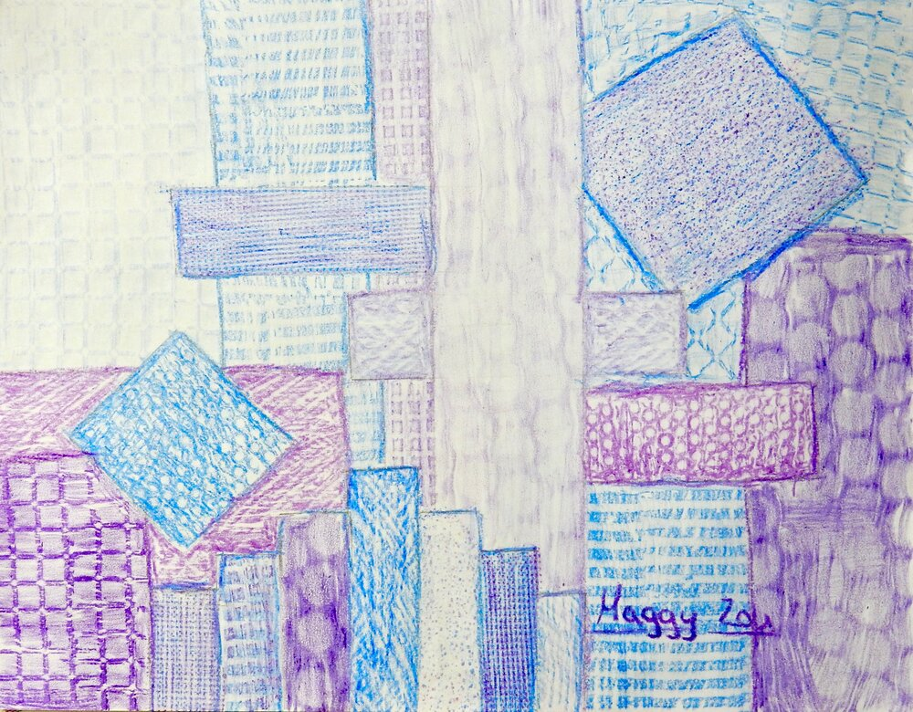
- Use different colors and change positions to create a unique design.
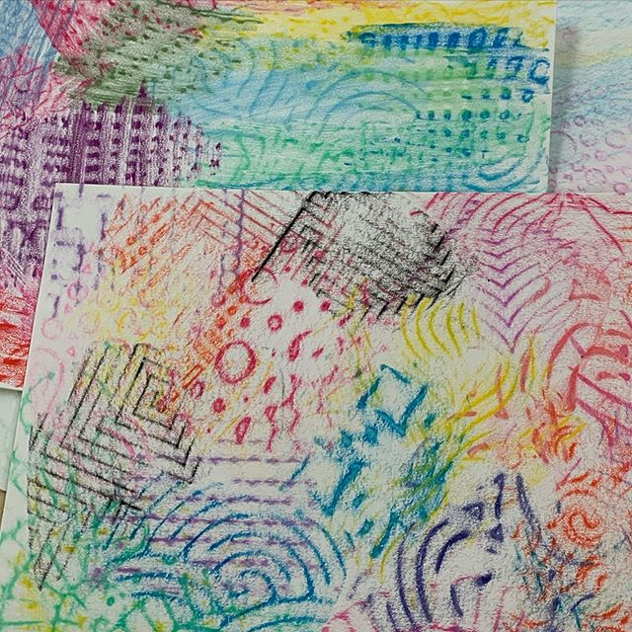

ART ACTIVITY: - CRAFT
RECYCLED PAPER BEADS
https://www.youtube.com/watch?v=jMG40809rws
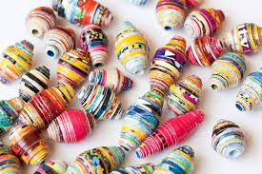
ART WEBSITES TO CHECK OUT:
https://www.redtedart.com/
https://www.nga.gov/education/kids.html
https://www.eduweb.com/pintura/
https://web.archive.org/web/20100314094903/http://www.albrightknox.org/artgames/html/home.html

PLEASE FEEL FREE TO EMAIL Mrs. (K.) Kasperowicz (katkas@hgaschool.org) with pictures of all of the cool artwork you are doing. I will try and post the images on my website (no names will be posted or images of children.)

May God carry all of our families through this difficult time. May He provide us with protection for our health and all families with financial safety also. St. Jude, Pray for us.
In Christ we pray. Amen
God’s Peace be with us all.
Mrs. Kasperowicz

